**NIKITA THAKUR**

**SOPHOMORE**

7021815065

111thakurnikita111@gmail.com

**SKILLS**

**Soft Skills**

Problem solving

Multi-tasking

Leadership

Communication

Organizational

**Technical Skills**

Python

C++

Numpy & Pandas

Problem solving

Figma

Canva

Scikit learn

Basics of Machine Learning

**EDUCATION**

**HIGHER SECONDARY SCHOOL**

ST. WILFRED SCHOOL

2019 - 2021

**SECONDARY SCHOOL**

RYAN INTERNATIONAL SCHOOL

**PROFILE**

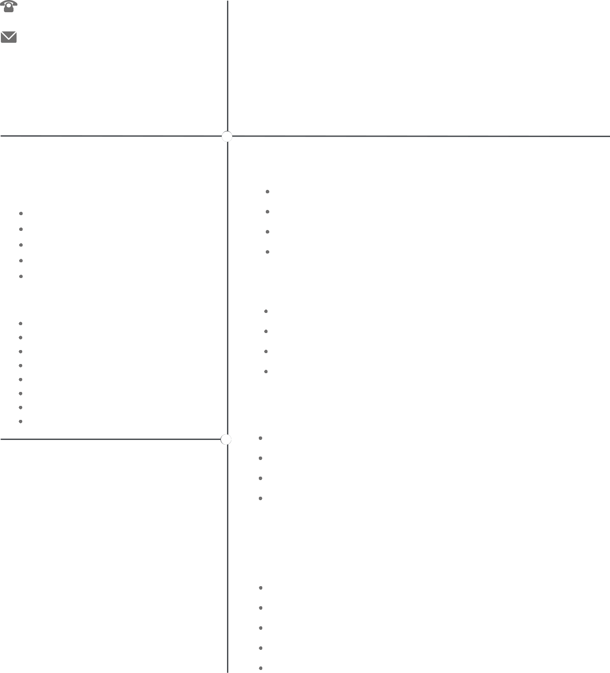

AI enthusiast, and am currently exploring ML and graphic designing.

Good with Python and C++ and have developed few projects in it.

Strong creative and analytical skills. Team player with an eye for detail.

Have good Leadership as well as Communication skills.

**ONGOING COURSES**

SUPERVISED LEARNING COURSE BY ANDRERW NG (COURSERA)

ACMEGRADE INTERNSHIP PROGRAM IN AI **(COMPLETED)**

NPTEL - INTRODUCTION TO MACHINE LEARNING (IIT KGP)

NPTEL - ARTIFICIAL INTELLIGENCE (IITM)

**PROJECTS**

NUMBER GUESSING GAME (PYTHON)

REPOSITORY OF PANDAS

TOWER OF HANOI (PYTHON)

USERNAME AND PASSWORD GENERATOR (C++)

**EXPERIENCE**

DESIGN COORDINATOR AT **GDSC DYPCOE** DESIGN COORDINATOR AT **ISA(DYPCOE)**

VOLUNTEERED TECHNICAL EVENT **(SAMBHAV)** ON BEHALF OF ISA VOLUNTEERED AT **GOOGLE CYBERSECURITY ROADSHOW** EVENT

**GRAPHIC DESIGNING**

**PROJECTS**

MANAGING UI/UX OF GDSC DYPCOE WEBSITE

LOGO FOR DAZZLE BOUTIQUE

BANNERS FOR DAZZLE BOUTIQUE

LOGO FOR INSTAGRAM PAGE

GAMING LOGO FOR YOUTUBE CHANNEL